Name:- Bhavsar Divyansh BirenKumar

Assignment of A+ N+ Assignment

Module 1 (Hardware And Its Comonents

Topic: The Visible Computer

**Basic:**

1. What is Hardware?

Ans: Hardware is Collection of all parts you can physically touch.

1. What is the purpose of Hardware?

Ans: The purpose of hardware is to provide the physical components and device necessary for a computer for a computer system function

**Intermediate :**

1. list out two types of hardware.

Ans: Input and Output Device

Important input devices which are used in a computer:

i Keyboard

ii Mouse

iii Joy Stick

iv Light pen

Important Outputdevices which are used in a computer:

i Monitor

ii Printer

Advance:

1. What is Core Hardware?

Ans: Computer hardware system consists of different types of devices. Each device is connected directly or indirectly to the motherboard. These are classified into three basic categories:

1. Input/OutPut device

2. System Unit

3. Storage Unit

Description Input/Output Devices:

User enters the commands and data through the keyboard or mouse, these data are translated into a form that computer can process. After processing the data, output devices converts it into human understandable format. Commonly used input/output devices are keyboard, mouse, monitor and printer.

System Unit:

Also called as system cabinet contains the most of the electronic components that make up a computer system. Important component is processor, which controls and manipulates data to produce information. Clock is used to synchronize the whole circuitry of the system. RAM (Random Access Memory) use to store temporarily data to read or write data onto the disk/memory. ROM (Read Only Memory) contains permanently stored programs such as monitor programs. Expansion slots are available on motherboard to enhance computer system by using graphics cards, sound cards, TV tuner card etc. Ports are connecting sockets on the system unit like monitor port, printer port, USB port, RJ45 port and audio port.

Storage Unit:

Attached hard disk inside the cabinet is mainly used as storage device, as it can store more data and faster than CD drive. But still CD (Compact disc) and DVD (Digital Video Disc) are used to store and transfer data from one pc to another

Q.2 Do a practical of identifying hardware.

Ans: 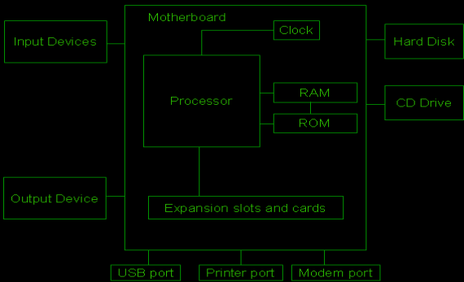

Topic: Category of components

**Basic:**

Q.1 What are the category of components in hardware?

Ans: Hardware Devices:

Keyboard, Mouse, Monitor, Printer, Ram, Rom, Graphic Card, CD, DVD

Q.2 Why category is neededS?

Ans:

Intermediate

1. Do a practical to identify the components in which category they come

Ans:

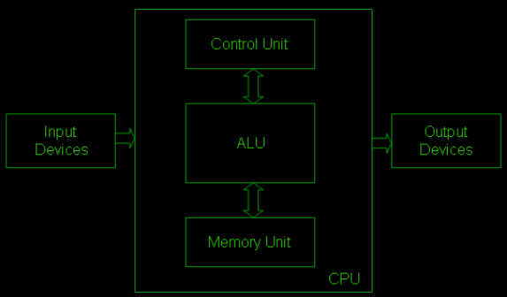

Topic : Input Device

• Assignment Level Basic

1. What is input device?

Ans. User enters the commands and data through the keyboard or mouse, these data are translated into a form that computer can process. After processing the data, output devices converts it into human understandable format.

Commonly used input/output devices are keyboard, mouse, monitor and printer

1. Why input device needed?

Ans. Input devices are essential components of computer hardware because they enable users to interact with and provide information to the computer system. These device serves as the means for users to input data, commands ,and other information into the computer .

• Assignment Level Intermediate

1. List out the input device.

Ans: Input and Output Device Following are few of the important input devices which are used in a computer:

• Keyboard

• Mouse

• Joy Stick

• Light pen

• Track Ball

• Scanner

• Graphic Tablet

• Microphone

• Magnetic Ink Card Reader(MICR)

• Optical Character Reader(OCR)

• Bar Code Reader

• Optical Mark Reader(OMR)

Topic: Output Device

• Assignment Level Basic

1. What are output device?

Ans: An output device is any piece of computer hardware that converts information or data into a form that can be perceived by humans or other devices. For example, a monitor is an output device that displays text, graphics, and videos on a screen. A printer is an output device that produces a hard copy of the information on paper. A speaker is an output device that plays sound or music.

2. how does output device work?

Ans: An output device works by receiving a signal from the computer and using that signal to perform a task to display the output. For example, if you type “H” on your keyboard, which is an input device, the keyboard sends a signal to the computer. The computer processes the input and sends a signal to the monitor, which is an output device.

• Assignment Level Intermediate

1. List out the output device.

Ans:

• Scanner

• Graphic Tablet

• Microphone

• Magnetic Ink Card Reader(MICR)

• Optical Character Reader(OCR)

• Bar Code Reader

• Optical Mark Reader(OMR)

Topic: Motherboard

• Assignment Level Basic

1. What is motherboard?

Ans: A motherboard is the main circuit board that connects and allows communication between the different components of a computer or other electronic device. It contains the CPU (central processing unit), the memory, and various connectors for peripherals such as keyboard, mouse, monitor, printer, etc. The motherboard also controls the power supply and regulates the voltage and current of the system.

2. Why it is called motherboard?

Ans: The term “motherboard” is used to refer to the main circuit board of a computer because it is the central hub that connects and communicates with all the other components of the system, much like a mother is the central figure in a family.

• Assignment Level Intermediate

1. What it is called if we remove all components from the motherboard?

Ans: If you remove all components from the motherboard, you will end up with a bare motherboard, which is just a circuit board with no functional parts attached to it. A bare motherboard is usually not useful for anything, unless you want to use it as a decoration, a coaster, or a frisbee.

2. Describe types of motherboard

Ans : There are different types and sizes of motherboards, depending on the design and purpose of the device. For example, a desktop computer may have a large motherboard with multiple expansion slots and ports, while a laptop or smartphone may have a smaller and simpler motherboard with fewer features. Each motherboard is designed to work with specific types of processors and memory, so they are not compatible with every device. Some common motherboard form factors are ATX, microATX, mini-ITX, and E-ATX .

Topic: CPU

• Assignment Level Basic

1. What is CPU.

2. Write the full form of CPU.

• Assignment Level Intermediate

1. What are the types of CPU?

2. What do we need to keep the CPU Healthy?